Converting the direct conversion HF SSB receiver to a Transceiver
By Juan H la Grange, ZS6SZ
- Introduction
The first document describes the receiver, this document describes how the receiver was converted to a transceiver.

As a reminder, the direct conversion, phasing method SSB receiver covers the range 1.8 to 30 MHz, and this transceiver does the same. Again, is specifically for radio amateur use and published for use by private enthusiasts and hobbyists.

It must be stated again that it uses and builds on the ideas of many other people. They will be recognised where applicable and known and the internet will provide even more references.

Components at hand were used where possible, thus no guarantee is given that those will be available for purchase or even that they may be optimal.

The rather obvious fact was discovered that the performance requirements of a transmitter are more onerous than that of a receiver (the spectrum and other users have to be respected; things that worked sufficiently well in the receiver were found to be no longer adequate), and this led to the partial redesign of a number of the modules as also described below.

The completed transceiver has an approximate 13dBm (20mW) output, amplifying this to a useful power output is the topic of the next document.

- Operating principles
As mentioned, the phasing or second method of SSB is used, which employs 90° phase shift in the local oscillator (LO) and audio frequency (AF) stages to filter out the unwanted sideband. The LO produces two signals which have a 90° phase difference and feeds these into two balanced mixers. From the microphone there are two audio channels, with both being shifted, one by +45° and one by -45°, also feeding into the balanced mixers. The two signals are combined after the balanced mixers and fed into the RF amplifier for output to an external RF power amplifier.

The balanced mixers cancel out the local oscillator carrier.

The same double-tuned RF stage is used as in the receiver to filter out harmonics and other unwanted products from the balanced mixers. As a matter of fact, most the receiver modules are used again in the transceiver. The description of those that were not changed from the receiver will not be repeated here.

- Block diagram

The simplified block diagram of the transmitter is as follows:

Splitter*
B
A
AGC 2
LPF 1.2
AGC 1
LPF 1.1
Hilbert phase shift 1 +45°

Mic*
Hilbert phase shift 2 -45°

LPF 2.1 and buffer **
Balanced mixer 1
A

Combiner 2, External RF Power amplifiers *
RF stage
RF Combiner 1*

0°
Local oscillator (VCO)
+90°

Antenna Tuning Unit and antenna
LPF 2.2 and buffer **
Balanced mixer 2
B

*Unique to the transmitter
** See 8. below
Figure 1. Transmitter simplified block diagram

In more simplified form, to enable showing where the change-over relays from receiver to transmitter are located:

Balanced mixer 1
COR2A
COR1

COR3A
COR1

Audio channel +45° *
COR6
Combiner, External RF Power amplifiers
COR1A

COR4A
COR5A
COR7
Local oscillator (VCO)
0°
+90°
RF stage
RF Comb.
Mic and Splitter
COR4B
COR3B
COR1

COR2B
COR1

Audio channel -45° *

COR1B
COR1

Antenna Tuning Unit and antenna
Balanced mixer 2

*Starting with the AGC stage, see 4.1 and 6 below.
Figure 2. Block diagram of the transmitter showing change-over relay location

- Change-over relays.
Fourteen pairs of contacts or 7 DPDT change-over relays are required to switch from receive to transmit and vice versa. These need to be located as close to their respective modules as possible. To prevent excessive power drain, it was decided to use DPDT double coil latching relays, with a front panel SPST centre zero spring loaded toggle switch to briefly select (but with enough time to switch the latching relays) transmit (Tx) or receive (Rx). A front panel red LED indicates Tx and a green one Rx, for which another relay is required.
The circuitry for the Tx / Rx toggle switch and each relay is as follows:
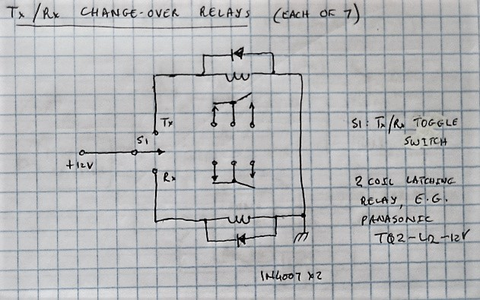

Because there are 8 COR’s fed from the toggle switch, a screw-down terminal block is used to distribute the power (actually a few are used for the sake of convenience, spread across the chassis).
The function and circuitry of each change-over relay (COR) will now be described. The COR numbering follows figure 2 above.
  - COR1: Selecting the AF input to the AGC stage
COR1 selects the audio input to the AGC stage between the output of the low noise AF amp (Rx) and the microphone splitter (Tx). (The low-noise AF amp is thus not used in the transmitter.)

  - COR2: Selecting the AF output
COR2 selects where the output of the AF stages goes, between the AF summation (Rx) and the balanced mixer (Tx).

  - COR3: Selecting the balanced mixer input
COR3 selects the input of the balanced mixer between the RF stage (Rx) and the AF output of LPF 2 (Tx).

The block diagram connections for COR1, 2 and 3 are as follows:

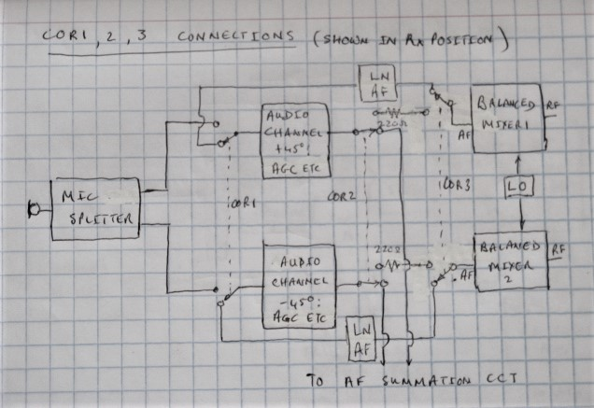

The resistors between COR2 and COR3 attenuate the AF signal for optimal input level into the balanced mixer and good RF linearity, determined empirically, using an oscilloscope (see also 8 below).

  - COR4: Selecting the balanced mixer output
COR4 selects where the output of the balanced mixer goes, between the AF low noise amplifier (Rx) and the RF combiner (Tx).

  - COR5A: Selecting the RF stage input
COR5A selects the input of the RF stage between the Antenna tuning unit (Rx) and the balanced mixer (Tx).

  - COR6: Selecting the RF stage output
COR6 selects where the output of the RF stage goes, between the balanced mixer (Rx) and the external RF power amp (Tx).

The block diagram connections for COR4, 5A and 6 are as follows:

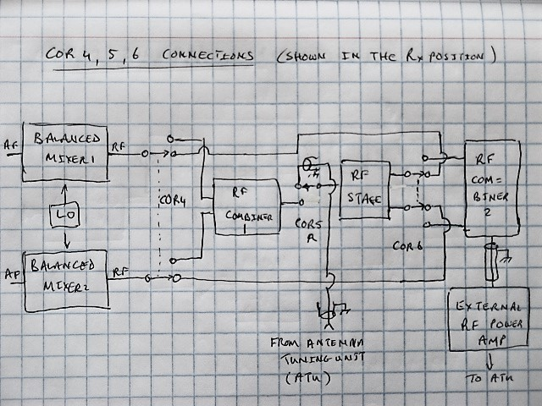

In addition, COR5B pre-sets the gain of the RF stage. Because the RF gain setting can be anything when receiving, it needs to be fixed when transmitting so that the output level to the external RF amp is independent of this setting, known and determined. See also 9.1 below.

  - COR7: Selecting where the antenna tuning unit is connected
COR7 selects where the antenna tuning unit is connected, between the RF stage input (Rx) and the RF power amp (Tx). Thus:

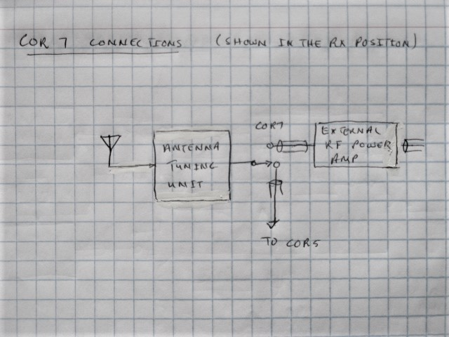

  - LED indicators
The circuitry for the LED Tx /Rx indicators is as follows:

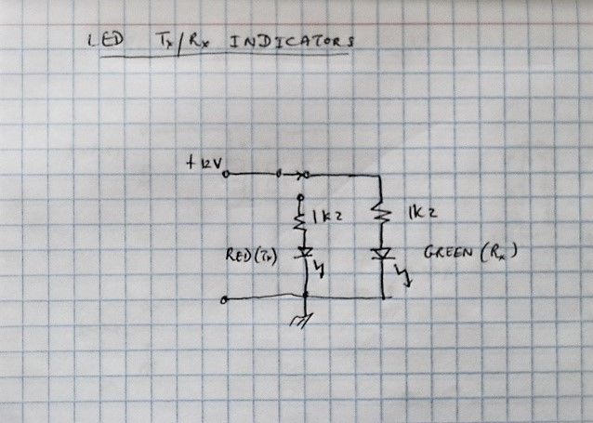

  - RF power amp blanking
If the RF power amp has the functionality to apply a blanking signal during Rx, this should be implemented using yet another set of COR contacts or a new COR.

- RF combiner 1
A simplified transmission line transformer combiner is used, as follows [Granberg, H, Broadband Transformers and Power Combing Techniques for RF, Motorola Semiconductor Application Note AN 749, 1993. and others]:
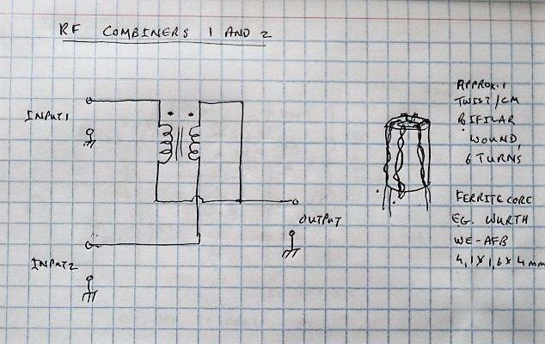
- Microphone splitter
The moving coil microphone output signal is large enough to go directly into the AGC AF stage, bypassing the low noise AF amp. Low-impedance buffering is provided, because the initial plan was to feed into the 50-ohm low noise AF amp. This however proved problematic since there was excessive noise present in the intra-speech pauses, due to the very high overall audio gain.
The circuit is as follows:
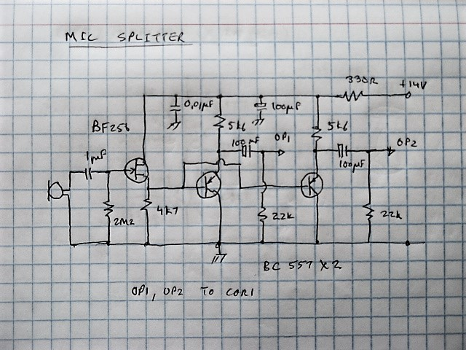

- Second RF combiner, external RF power amp
Since the output of the RF stage is via two actively driven buffer stages, it was decided to also combine these to effectively double the RF output power. It is identical to RF combiner 1 (see 5 above).
The combiner feeds external RF power amplifiers. Any linear amplifier(s) can be used, the author selected to use a wideband Lusya (China) set. The output to the power amp is about 13 dBm (20mW into 50 ohm). The detail will be described in a next document.

- LPF2 Buffer
It was found that LPF2 could not drive the low impedance of the balanced mixer without clipping the signal and thus a buffer had to be inserted between this filter and the mixer.
To save on quiescent current, a class AB buffer was used. Component values and matching semiconductors did not seem critical, probably because high fidelity is not required.
It is fed from the -14V rail to balance the power supply loading.
A resistor is placed in series with the output, between COR2 and COR3, to reduce the AF signal to the balanced mixer for optimal RF stage output (see 9.1 below and 4.4 above). These don’t affect Rx.
The question then arises if the buffer is really necessary if the resistors are added in series. The last stage of the LFP is quite heavily loaded by its feedback network and the 741 op amps for this stage had to be hand selected, not all 741’s could produce the required output. (This should have been mentioned in the Receiver document, its omission was an error.) Thus, the buffer is required to not further load the last stage.
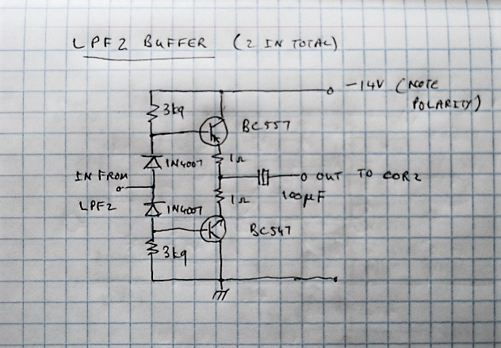

The 1-ohm emitter resistors provide some negative feedback and thus improve stability.
- RF Stage
  - RF amplifier

It was found that it had to be possible to lower the RF gain in Rx to a greater extent than the original design allowed. To this end, the 68k resistor in the gain control circuitry was replaced by a 33k resistor, which now allows the FET to be driven into the pinch-off region.

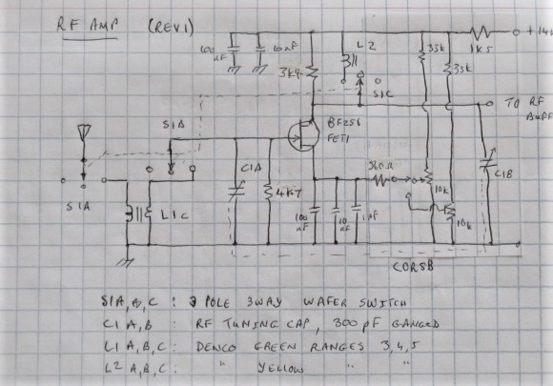

As mentioned, the RF gain in Transmit is pre-set by COR5B. This allows the audio signal levels into the balanced mixers to be pre-set for optimum RF stage output signal linearity and output level (see also section 8 above).

By improving the screening and layout, it was possible to increase the values of the resistors in parallel with the tuned circuits, improving Q and selectivity; and thus the filtering out of unwanted and spurious signals before they reach the wide-band RF power amp.

  - RF Buffer (Rev 2)

It was seen that the RF buffer, which feeds the external wideband RF amplifier and thus needs to be linear and produce a spectrally pure signal, clips, distorts and attenuates the rather large (1Vrms typical) RF output of the RF stage when transmitting. Since COR5B puts the RF gain at maximum, large signals can be expected in transmit due to this large gain. Bandwidth was also limited to about 15 MHz, which was not known or suspected. Again, a class AB circuit was used to replace it, with comprehensive testing this time. The problems were mostly caused by the FET, it was replaced by a “normal” transistor emitter follower to present a high impedance to the RF tuned circuit. The biasing diodes are the base-emitter junctions of BC557 transistors, to match the transistors. Quiescent current through the complementary transistors is about 2 mA.

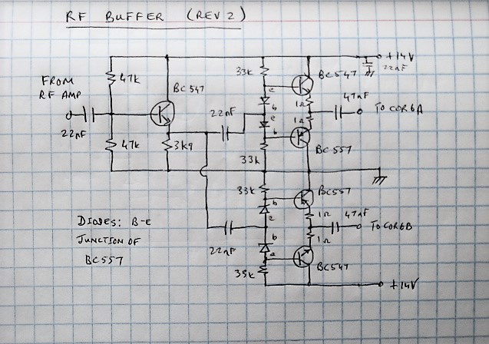

The dual buffers are of course not required for the transmitter (the two signals are simply combined after this stage). They are important for the receiver though, where they connect to the two balanced mixers. Since the LO signals feeding the mixers are not identical, they are 90° apart, the one should not be allowed to leak through to the other through the RF stage.

- VCO 2
It was found that the spectral purity of VCO 2 was not adequate at the 7 MHz and higher amateur bands. This mainly shows up in Tx, as the narrow AF bandwidth and the AGC in Rx mostly eliminates the problem. The VCO 2 spectrum contained strong spurious sidebands / signals relatively close to the carrier, which the RF stage could not filter out.

The solution was to change the loop filter of the PLL, by adding an (empirically determined) 10 microfarad capacitor in series with a 4k7 resistor.

The oscillator capacitor for range 3 was increased from 20 to 27 pF due to the PLL locking onto a spurious frequency.

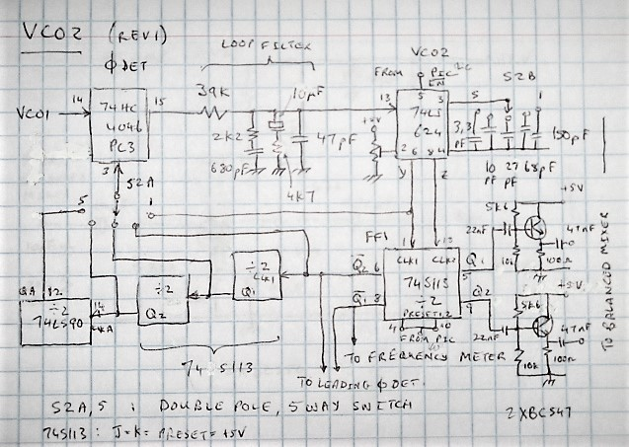

The VCO2 spectral purity, as seen on a spectrum analyser, is now acceptable in all the amateur bands but the sidebands problem persists at some other (unlicensed) frequencies, which should not be an issue for this amateur band transceiver.

- Low noise AF amplifier
With the improved RF buffer now passing a non-attenuated signal, the audio gain in this stage was found to be too high, leading to the constant saturation of the AGC stage with noise even when there was no signal. This led to the removal of the FET output stage to reduce the gain.

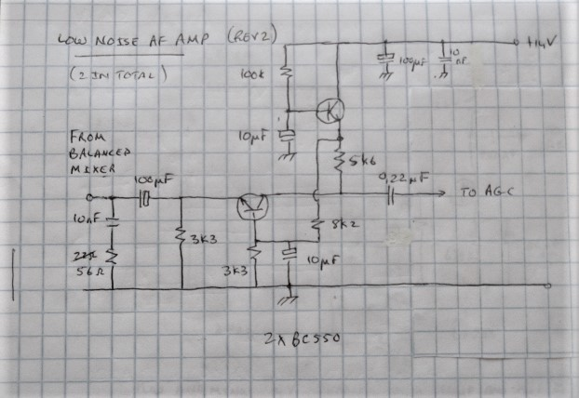

- Setting up and performance

  - Setting up
After the installation of the CORs, the correct operation of the receiver needs to be confirmed of course. Thereafter the transmitter needs to be checked for correct wiring (and problems traced and corrected, as the author had to do).

There are very few adjustments available for the transmitter, but the following can be checked.

With no microphone connected, the RF output will be zero (in theory), in practice there will be some noise output. Check this output.

Inject an audio sine wave of say 1kHz into the microphone port and check its progress stage by stage, both audio channels. Confirm that at the output of the LFP2 buffer, the two audio signals are 90⁰ apart, with a dual-channel oscilloscope (although confirming receiver operation would have largely done this already).

Terminate the output of RF Combiner 2 with a 50-ohm resistor, select the 80m amateur band (remember to do this with both the frequency setting and the RF tuning) and check the output signal. It should be a sine wave. Check its spectrum for purity. Adjust the pre-set resistor in the RF amplifier for optimal amplitude and purity. Fine tuning of the RF LC circuits could be considered.

The output signal could show traces of the unwanted side band. This will show up as a modulation of the signal:

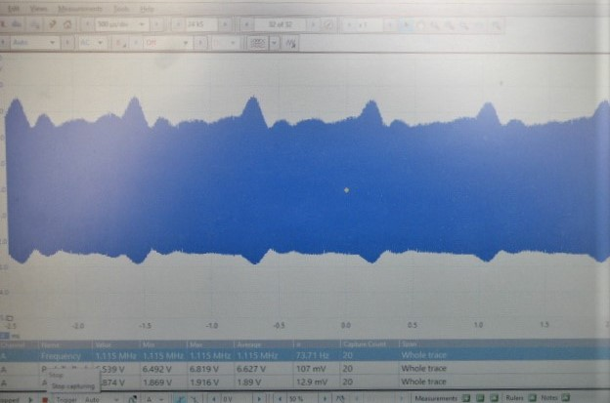

The author found his PC-based Picoscope combined oscilloscope and spectrum analyser very useful for the above.

Repeat for all the amateur bands.

Then add RF power amplifier(s), tune the antenna tuning unit at low power, increase the power and enjoy your hamming!

As a reminder, the output of each of the balanced mixers will consist of two sidebands around the selected frequency with the carrier suppressed (and with a lot of harmonics due to the square wave LO signal). This can be checked with a spectrum analyser. When the outputs of the two balanced mixers are combined, the desired sidebands will be in phase and thus add; the undesired sidebands will be 180° out of phase and cancel out. The harmonics will persist through Combiner 1 until filtered out by the RF stage.

For information, the RF output of each of the balanced mixers looks as follows:

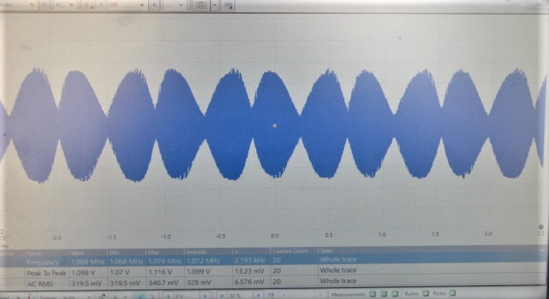

  - Performance
The suppressed carrier is some 37 dB below the desired signal.

- Conclusion

The conversion of the receiver to a transceiver is not a trivial exercise although well worth the effort. The biggest challenges were “large” RF & AF signals (1Vrms) combined with “low” impedance (50 ohm) which necessitated several design changes; improving the spectral purity of VCO 2; finding space in the chassis for all the extra circuitry and wiring (and then finding and fixing stupid wiring errors around the COR’s etc.).

The next challenge is to amplify the transmit signal and couple it effectively to the attic antenna of the author. This operationalisation will be the subject of a next paper.

